8) You have a Cisco switch and a VoIP phone that needs to be placed in a voice VLAN (VLAN 20). The data for the PC should remain in a separate VLAN (VLAN 10) Configure the switch port to support both voice and data traffic.
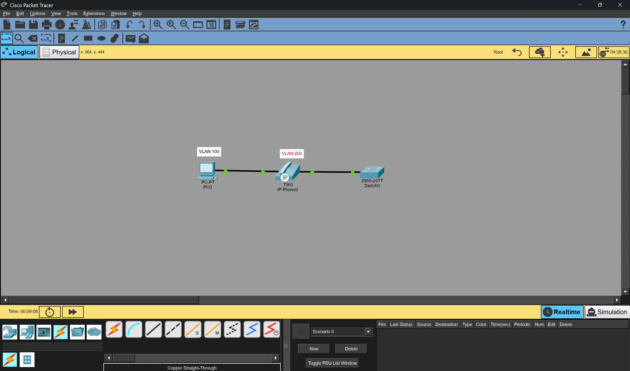
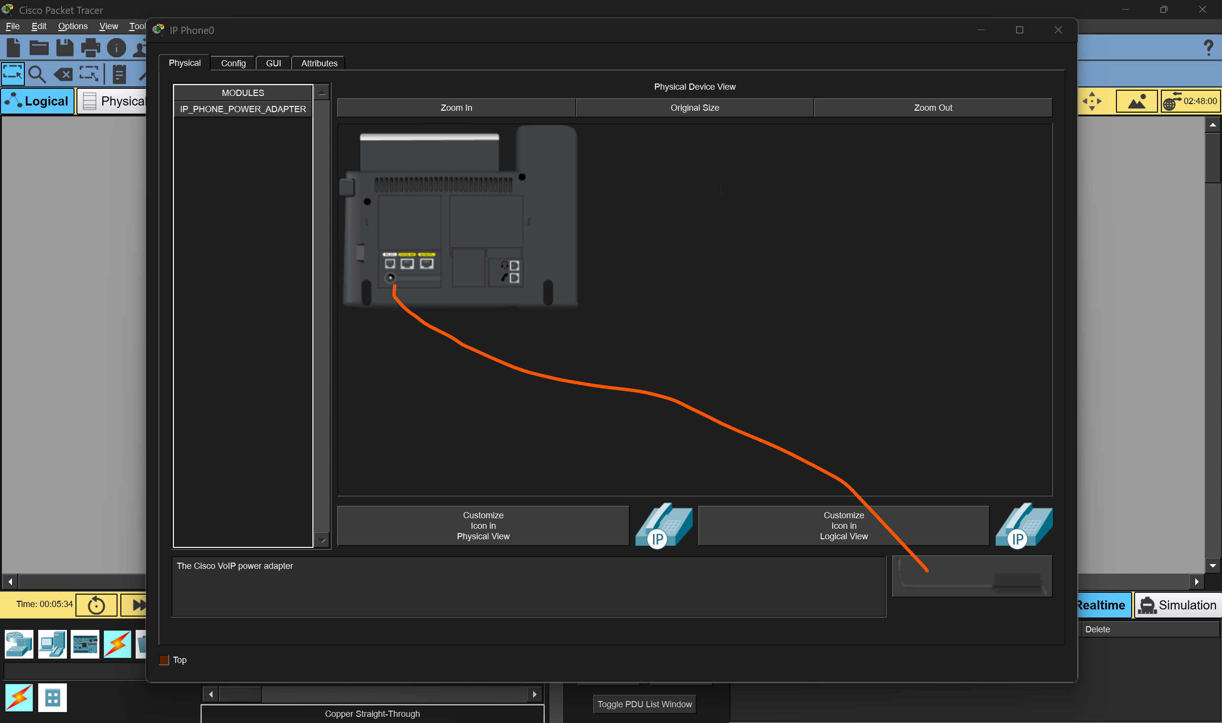
- Drag the cable to the port
